Project Scope:
The project scope was creating and using a Random Forest Regression that tested whether IDS data was benign or an anomaly.

Project Objective:
The objective of this project was a test of the research and training that had been worked on in Week One as well as a test of a new model, Random Forest Regression, that had not been worked with before.

Dataset Used:
All datasets used were taken from this Network Intrusion dataset from 2017 of a week of recorded activity involving attacks. The original dataset was from the Tuesday of the recorded week, the second dataset was from Wednesday as there were problems with the original dataset (explained more in Problems Encountered).

Cleaning Method:
[data1.columns = data1.columns.str.strip()] → This code stripped all whitespace from the labels as there were problems with spacing in said labels.

[data1["Label"] = (data1["Label"] == "BENIGN").astype(int)] → This code converted the “Label” objects into integers, having BENIGN become 1 and all attacks become 0).

[data1.rename(columns={data1.columns[55]: "Fwd Header Length"}, inplace=True)]
[data1.rename(columns={data1.columns[66]: "Init Win Bytes Fwd"}, inplace=True)]
[data1.rename(columns={data1.columns[67]: "Init Win Bytes Bwd"}, inplace=True)]
[data1.rename(columns={data1.columns[68]: "Act Data Fwd Packets"}, inplace=True)]
[data1.rename(columns={data1.columns[69]: "Min Seg Fwd Size"}, inplace=True)]

The five lines of code above normalized the mislabeled data into the same format as the rest of the dataset.

[data1 = data1.drop_duplicates()] → This code dropped all duplicates from the dataset.

[data1.replace([np.inf, -np.inf], np.nan, inplace=True)] → This code replaced all infinite values with missing values.
[data1_cleaned = data1.dropna() → This code then dropped all missing values.
Model Objective:
The objective of the model was to be able to classify the IDS dataset as either benign or as an attack.

Benign/Attack Distribution:
Benign = 68.26%
Attack/Anomaly = 31.74%

Results and Statistics:
With 200 Trees and the Wednesday Dataset: About 1.5 hours to run
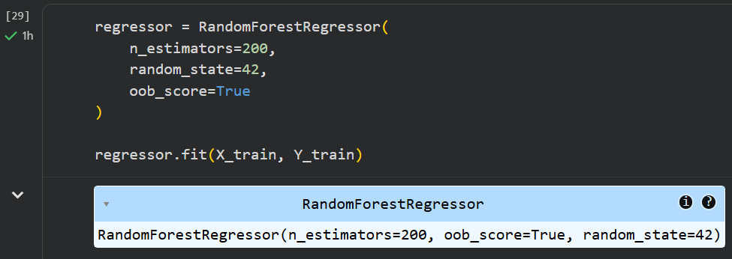
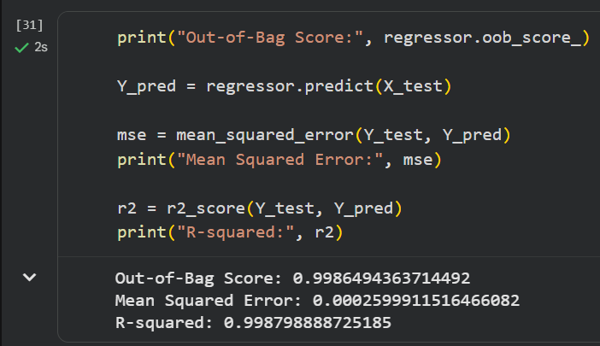
Accuracy, Precision, F1-Score, and Confusion Matrix (200 Trees):
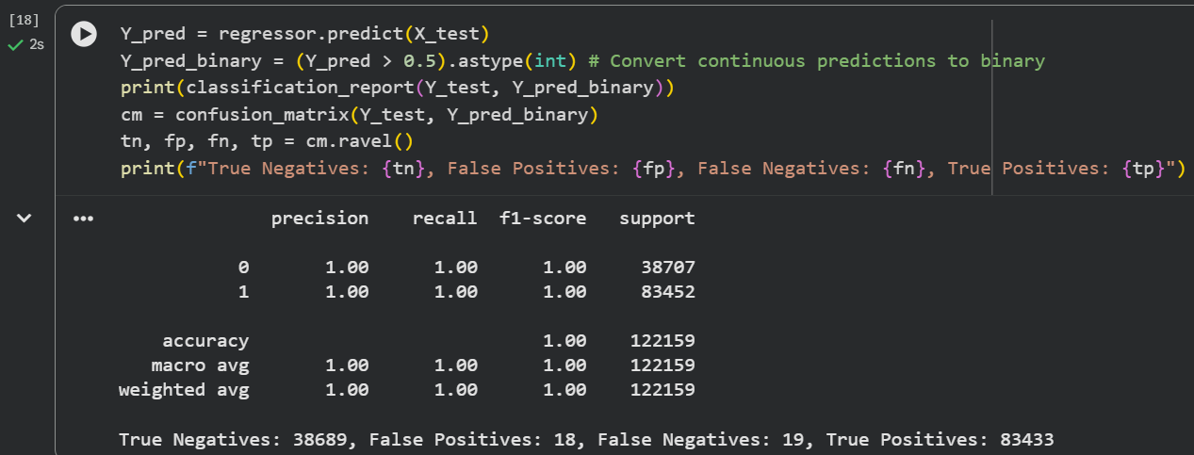

With 100 Trees and the Wednesday Dataset: About 45 minutes to run
Same Results as Above

With 50 Trees and the Wednesday Dataset: About 22.5 minutes to run
Same Results as Above

With 25 Trees and the Wednesday Dataset: About 11.5 minutes to run
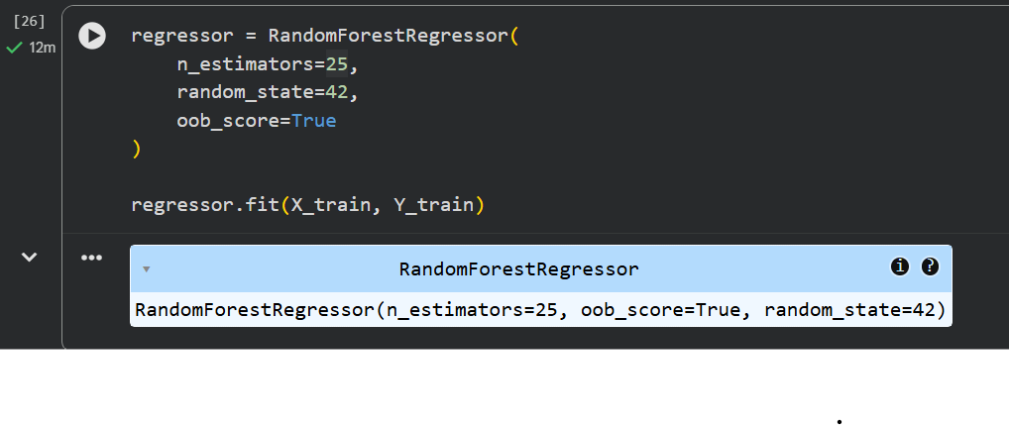
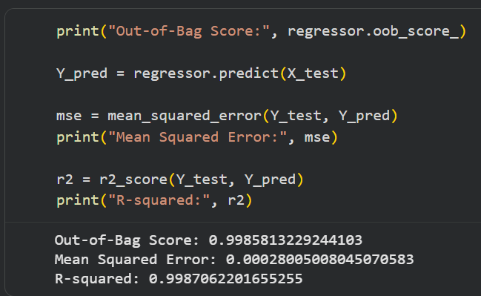
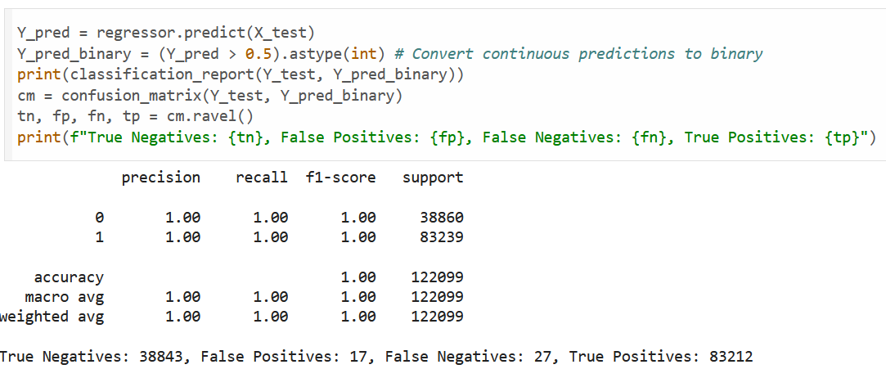

As seen above, there was no change in accuracy loss (as seen by the out of bag score of 99.86% between the three models) between 200, 100, and 50 trees. At 25 trees, there was a 0.002% drop in accuracy quality with a fall in false positives and rise in false negatives (18 → 17 for positives, 19 → 27 for negatives).

For each halving of trees, there was a halving of runtime.

Problems Encountered:
One problem encountered was not examining datasets as closely as needed as the Tuesday dataset turned out to have an unbalanced ratio of 90% benign to 10% attack examples. Because of this, the Wednesday dataset was chosen instead as it had a much better ratio of 68.26% to 31.74%.

Another problem was inefficiency due to misreading instructions as time was spent researching unnecessary topics such as dropping labels from datasets.

